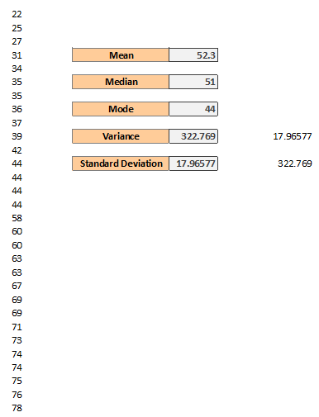

**Calculating Measures of Central Tendency using Excel:**

* We have calculated the **mean** (average) of 30 scores.
* **Median** is the score in the middle of the dataset when the data is arranged from lowest to highest. Here we have even number of scores. It’s the average of the two scores in the middle.
* **Mode** is the score and the dataset that appears the most number of times. In our case, it is 44 as it appears four times and that is why it is the mode.
* Mostly for measures of a dispersion will be mostly be using **standard deviation**. So, the standard deviation tells us the average distance that any particular score is from the mean so it’s the measure of dispersion in the dataset.
* The relationship between **variance** and **standard deviation** is the square root of the variance and the variance is the square of the standard deviation.